**North South University**



**Department of ELECTRICAL AND COMPUTER SCIENCE**

**PROJECT PROPOSAL**

**COURSE: CSE-299**

**SECTION-19**

**GROUP-06**

**Date of Submission: 14 March, 2019**

**SUBMITTED BY-**

|  |  |
| --- | --- |
| **NAME** | **ID** |
| **MOIN SHAHRIYAR** | **1610586042** |
| **SARHAN OSMAN BHUIYA** | **1611008042** |
| **FARJANA ALAM** | **1620060042** |

**INTRODUCTION**

Our target is to present an omnidirectional sonar vision device that can assist visually impaired individuals. It will provide autonomous navigation for an unknown environment. The device will use multiple sonar sensors with prior calibration and detects static and dynamic obstacles. It estimates the most intended path based on visual sonar beams in all directions of the individual and provide results in the form of vibration through vibrators fixed around the head. The more closer an individual gets to an obstacle the more intense the vibration gets. We shall present a wearable and portable assistive devices for visually-impaired people in order to show the progress in assistive technology for this group of people.

**FEATURES**

* Determining obstacles around the user body from the ground to the head
* Providing information about the distance between the user and the obstacle with essential vibrating intensity
* Affording information to give the ability of self-orientation and mental map of the surroundings
* Providing mobility instructions and paths to guide the user and develop her/his brain about the environment.
* Google navigation to a specific address or location by using headphones

**BLOCK DIAGRAM**

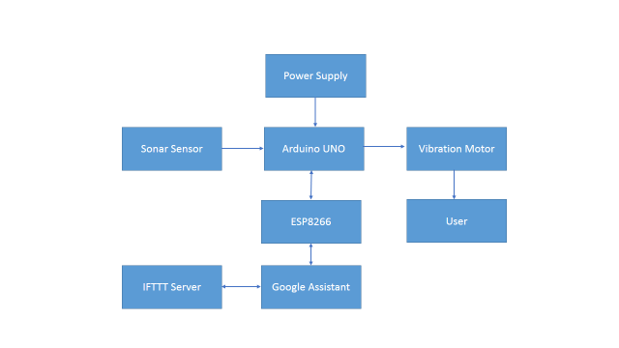

**MECHANISM**

* There will be a wearable hat with sonar in eight direction which will cover 360˚.
* The sensors will be in such angle so that there will be created a circle of ultrasonic waves around the user which will cover from his neck to toe.
* To sense the location of the object there will be small vibration motor in eight direction also. So that the user can get clear sense about the object’s location.
* If the object is moving vibration motor will vibrate according to the direction.
* There will be extra 1 sonar at vertical direction to cover user’s head at straight direction.
* There will be extra 2 vibration motor one could be placed in user belt which will only vibrate when there will be any object at middle direction. Thinking of railway gate/parking gate. Only for those type of object, this motor will vibrate.
* The other vibration is for any hole ahead of user or think about stairs. The user will be notified if there is hollow ahead of him. Could be placed in hand.
* There will be a mobile app along with the hardware which will start by voice command of the user, it will be able to set destination, provide voice assistant for walking etc.
* Two bone conduction speaker will be provided behind the ear of the user (similar to Zungle Smart sunglass). These speakers will be attached with the main device.
* Most importantly as our sensors will be placed in an angle so that the app will be able to take base range for the sonar automatically. May be 30 sec of standing still after giving voice command for example: “Set my base range”.
* There could be one question “What will happen if the user sits after activating the project as there is a vibration function for middle range?”
* Yeah there will be a command for that, like if the user say “I am sitting right now” the vibration will be turned off.

**CHALLENGE**

Our device has to be user friendly for those who is visually impaired. Firstly the system needs to provide a fast processing for the exchanged information between the user and sensors.

To operate the device visually impaired people need some practice to understand the distance of any obstacles through the intensity of vibration.

In our future implementation we will connect our device with the GPS so that visually impaired people can set their destination and detect current location through their voice command so that it will be very easy to operate and set automated for different users.

**CONCLUSION**

Although a number of electronic travel aids that utilize sonar have been developed none appear to be in common use, and very few provide information other than range finding or a processed localization cue. In our project we proposed a device help detect visually impaired people from obstacle. Our system is designed keeping in mind that users are visually impaired people, the information representation is simple. By using this device they feel confident and they can easily move from one place to another by their own.